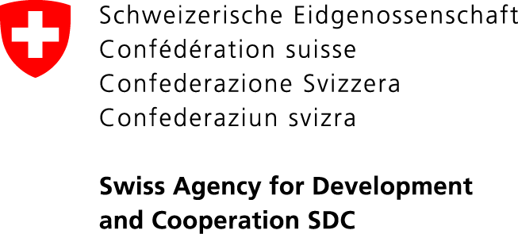

“Voice of Citizens and Accountability of Local Self-Governments: Budget Process” Project
108 Umetaliev Street, Bishkek, 720001, Kyrgyz Republic. Tel. (0312) 97-65-30 (31, 32), Fax: 97-65-29, office@dpi.kg, www.vap.kg

13 August 2018
Kyrgyzstan PRESS RELEASE

DEPUTIES OF ZHAZY AIYL KENESH WILL HAVE AN OPEN SESSION
TO ADOPT THE LOCAL COMMUNITY CHARTER

The open session on the adoption of the local community charter (LC Charter) will be held on August 14 in the village of Kara-Dyikan of Zhazy aiyl aimak, Uzgen rayon, Osh Oblast.
About 70 representatives of local self-government bodies (LSGs) represented by heads of aiyl okmotu and deputies of local keneshes from 35 municipalities of Osh oblast and the official representative of the State Agency for Local Self-Government and Interethnic Relations (SALSGIR) under the Government of the Kyrgyz Republic are also invited to the open session of the deputies of Zhazy aiyl kenesh.
“Charter of local community (city, aiyl aimak) is a document of the local community that defines rights, duties and relations between community members, between the community and aiyl okmotu, deputies of the local kenesh. After a series of public discussions and a general gathering of the local community, where amendments and additions were made to the draft document, the local kenesh deputies will have to draw a line in order for the community to comply with the rules of public order necessary for citizens, and the local self-government bodies to promote this compliance.

The local kenesh meeting will be held in the “open session” mode with full compliance with the requirements of legislation and regulations. After the session of Zhazy local kenesh, guests who participate in the experience sharing event will talk about the preliminary work done, information campaign and other aspects of holding open sessions of the local representative authority. During the exchange tour, the participants will have an opportunity to share experiences both in organizing and holding open sessions, and share information about the LC charters’ discussion outcomes in their aimaks, and also discuss the work of the administrative commissions. The local community requires from the LSG bodies the observance of order, including the procedure established by the Charter. This can be achieved through a dialogue and cooperation between LSG bodies and the population, as well as through the organization of the administrative commissions. After the adoption of the LC Charter by the aiyl kenesh deputies, the Charter will need a registration in the territorial subdivision of the Ministry of Justice of KR and informing the population,” says Roza Suranchieva, Project specialist working with LSG bodies.

The exchange tour is organized in the framework of the “Voice of Citizens and Accountability of LSG: Budget Process” project, financed by the Government of Switzerland through the Swiss Agency for Development and Cooperation (SDC) and implemented by the Development Policy Institute.
For details about the event: Nurgul Jamankulova, Public Relations specialist, Development Policy Institute, tel.: (0770) 771-711, (0555 / 0500) 313-385, email: njamankulova@dpi.kg, websites: www.vap.kg, www.dpi.kg

In accordance with Articles 509 and 534-1 of the Code of Administrative Responsibility of the Kyrgyz Republic the Commission is authorized to review cases of administrative violations within the competence of the local state administration or executive bodies of local self-government, in accordance with the Code of Administrative Responsibility of the Kyrgyz Republic. The main functions of the Commission are the examination of cases of administrative violations and the imposition of an administrative penalty, referred to its competence in accordance with the legislation of the Kyrgyz Republic. (As amended by the Resolution of the Government of KR as of February 2, 2018, No. 77)
The Project is aimed at increasing openness and efficiency in the management of LSG bodies by means of the local budget, facilitating the citizen participation in the budgetary process at the local level, in building dialogue between the population and LSG bodies and taking into account the needs of the population when making decisions by LSGs.

