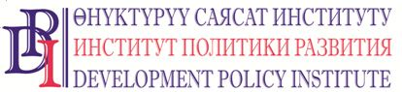
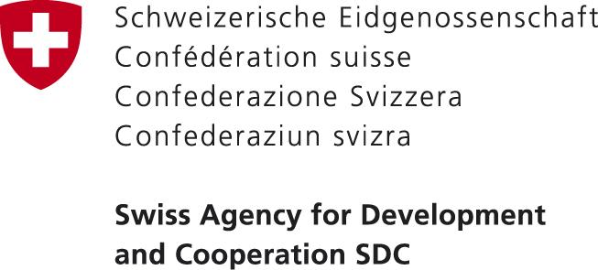

20 November 2017 PRESS RELEASE
Bishkek, Kyrgyzstan

FINANCE DEPARTMENTS SPECIALISTS OF AIYL OKMOTU IN OSH AND NARYN OBLASTS WILL IMPROVE THEIR SKILLS WITH NEW AUTOMATIZED SYSTEM

In November and December 2017, trainings on preparation, acceptance, selection, financing, and implementation of projects by means of equity (incentive) grants will be conducted in Osh and Naryn oblasts. The trainings will aim to provide representatives of local self-government (LSG) bodies with knowledge and skills of preparing proposals for improvement of urban and rural infrastructure in the Kyrgyz Republic through the incentive (equity) grants including automatized procedures of proposal submission and reporting.
The workshops are organized by the Ministry of Finance, the Training Center of the Ministry of Finance of KR, and the “Voice of Citizens and Accountability of LSG: Budget Process” Project financed by the Government of Switzerland through the Swiss Agency for Development and Cooperation (SDC), and implemented by the Development Policy Institute. The trainings participants are 175 representatives of rural local self-governments, rayon administrations, and rayon finance departments from Osh and Naryn oblasts.
According to Bolot Kasymov, chief specialist of the Equity Grants Department at the Ministry of Finance of KR, during the trainings the participants will obtain information about new automatized procedures of proposal submission for incentive (equity) grants, selection and approval of projects, work of commissions in selection and approval of projects.
“In 2016, the Ministry of Finance of the Kyrgyz Republic had developed and tested the automatized system of acceptance, registration, selection of projects according to the ‘Incentive (equity) grants’ line.” The system is functioning in a full mode across the entire republic. In addition, there were amendments to the Government Decree #230 as of 21.04.2015 “On Adoption of Regulations of Selection and Financing of Projects through Equity (Incentive) Grants and Instructions for Preparation and Implementation of Projects.” In result of the workshops the specialists of finance and economic departments of aiyl okmotu will improve their skills to respond to the citizen’s needs” commented Bolot Kasymov.
For more information about the workshops please contact Nurgul Jamankulova, Public Relations Specialist of the Project, tel.: (0770) 771-711, e-mail: njamankulova@dpi.kg, websites: www.vap.kg, www.dpi.kg

