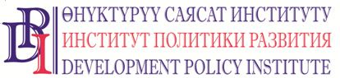
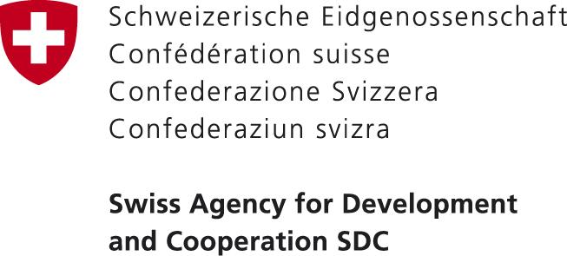

20 November 2017 PRESS RELEASE
Bishkek, Kyrgyzstan

LOCAL SELF-GOVERNMENTS OF FIVE OBLASTS WILL LEARN AND DISCUSS STANDARD REGULATIONS OF AIYL OKMOTU AND DRAFT LSG DEVELOPMENT PROGRAM OF KR FOR 2018-2022

During 20 November – 25 December 2017 in Naryn, Osh, Issyk-Kul, Jalal-Abad and Chui oblasts of Kyrgyzstan, three-day training workshops will be conducted for the heads of executive bodies of local self-governments (LSG). During the workshop participants will learn and review processes of administrative commissions’ work under the LSG bodies, discuss Standard Regulations of aiyl okmotu and its application in the operations of aiyl okmotu.
This training activity is organized by the “Voice of Citizens and Accountability of LSG: Budget Process” Project (VAP) financed by the Government of Switzerland through the Swiss Agency for Development and Cooperation (SDC) implemented by the Development Policy Institute (Project) in partnership with the State Agency for Local Self-Government and Interethnic Relations under the Government of KR (SALSGIR) and the Local Self-Governments Union of the Kyrgyz Republic (LSG Union).
During the workshops participants will also discuss a draft Local Self-Government Development Program of the Kyrgyz Republic for 2018-2022 developed by SALSGIR with the expert support by the Development Policy Institute. In addition, representatives of the LSG Union will provide the participants with information about its current activities, procedure of obtaining a membership with the LSG Union for the LSGs, as well as about its work plan for 2018 and onwards.
“Our Project aims at more transparent and efficient management of local budget funds by the local self-government bodies through increased accountability to local communities and more active involvement of citizens in decision making process at the local level. Such training workshops help us achieve our goal in increasing capacity of the executive bodies of LSG in prevention of violations and organization of the administrative commissions’ work on administrative violations under aiyl okmotu, increasing efficiency of aiyl okmotu apparatus through regimentation and planning its activities. Five workshops held in 5 oblast centers will cover 385 leaders of aiyl okmotu: 63 heads of AO in Naryn oblast, 61 heads of AO in Issyk-Kul oblast, 68 heads of AO in Jalal-Abad oblast, 88 heads of AO in Osh oblast, and 105 heads of AO in Chui oblast”, commented Bekbolot Bekiev, VAP Team Leader.
The workshops will also provide an opportunity for the leaders of aiyl okmotu to have an open and constructive discussion of the draft LSG Development Program of KR for 2018-2022 with the Project experts, the representatives of SALSGIR and LSG Union; to get familiarized with the procedures of organizing the administrative commissions on the ground and regulating operations of aiyl okmotu apparatus; to get clarifications about certain norms of legislation based on practical examples and presentations, gain information about the LSG Union activities, how to interact with it, as well as forms of arranging partnership relations.
For more information about the workshops please contact: Nurgul Jamankulova, Public Relations Specialist of the Project, tel.: (0770) 771-711, (0555) 313-385, e-mail: njamankulova@dpi.kg, www.vap.kg

